EXPERIMENT-4
NAME: ARIFA H
ROLL NO: 240701047
Create a prototype with familiar and unfamiliar navigation elements. Evaluate ease of use with different user groups using proto.io
Screen 1:
Sign In Page – BrewWay Smart Coffee Shop
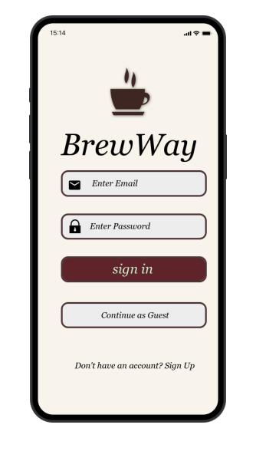

Familiar Icons:
- Email Icon (✉) – Inside Email Field
  - A universally recognized symbol for email input.
  - Indicates where users must enter their registered email address.
- Lock Icon (🔒) – Inside Password Field
  - Commonly used to represent secure password entry.
  - Suggests that the field is protected and encrypted.
- Sign In Button – Center of Screen
  - Standard call-to-action (CTA) button.
  - Clicking it authenticates the user and navigates to the Home screen.
- Phone Status Bar (Time, Battery, Network)
  - A standard mobile interface element.
  - Indicates device status information.

Possibly Unfamiliar Elements:
- Coffee Cup Logo – Top Center
  - Represents BrewWay brand identity.
  - Unique branding element specific to this application.
- Continue as Guest Option
  - Allows limited access without login.
  - Not present in all apps but common in e-commerce platforms.

Screen 2:
Home Page – Coffee Browsing Screen
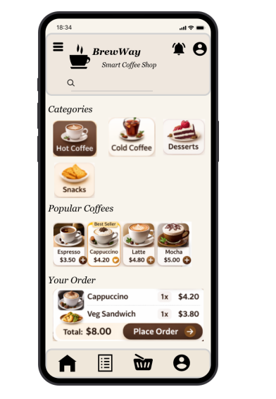
Familiar Icons:
- Hamburger Menu (☰) – Top Left
  - Widely recognized navigation icon.
  - Opens sidebar or additional navigation options.
- Search Icon (🔍) – Below Header
  - Used for searching products within the app.
  - Clicking activates search functionality.
- Notification Bell (🔔) – Top Right
  - Indicates alerts, offers, or order updates.
- Profile Icon (👤) – Top Right
  - Represents user account section.
- Cart Icon (🛒) – Bottom Navigation
  - Used to view selected items before checkout.

Possibly Unfamiliar Elements:
- Coffee Category Cards (Hot, Cold, Desserts, Snacks)
  - Designed specifically for BrewWay theme.
  - Though card layout is common, content is brand-specific.
- “Best Seller” Tag
  - Highlights popular products.
  - Styled uniquely for this app.

Screen 3:
Product Details Page
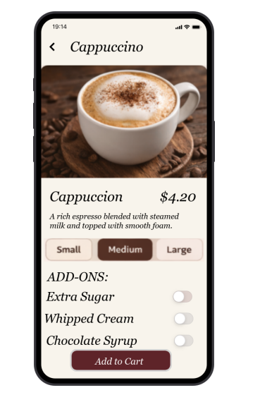
Familiar Icons:
- Back Arrow (←) – Top Left Corner
  - Common navigation control.
  - Returns to previous screen.
- Plus (+) and Minus (−) Icons – Quantity Selector
  - Used to increase or decrease quantity.
  - Standard in shopping applications.
- Add to Cart Button – Bottom Section
  - A primary call-to-action button.
  - Adds selected product to cart.

Possibly Unfamiliar Elements:
- Size Selection Buttons (S / M / L)
  - Specific to beverage customization.
  - May differ in design across apps.
- Add-ons Section (Extra Cream, Sugar Level)
  - Customized interaction element unique to coffee ordering.
Screen 4:
Cart & Checkout Page
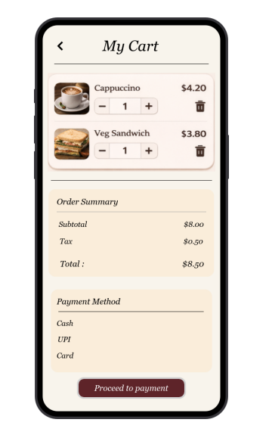

Familiar Icons:
- Back Arrow (←) – Top Left
  - Returns user to previous screen.
- Delete / Trash Icon (🗑️) – Next to Items
  - Used to remove selected product from cart.
- Quantity Control (+ / −)
  - Modify item quantity.
- Payment Method Icons (Card / UPI / Wallet)
  - Standard financial transaction indicators.
- Proceed Button – Bottom Section
  - Used to continue to payment confirmation.

Possibly Unfamiliar Elements:
- Total Summary Section Design
  - Styled uniquely with coffee-themed colors.

Screen 5:
Order Confirmation Page (Merged Payment + Success)
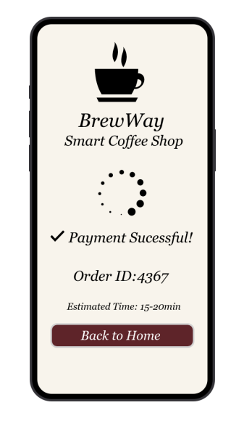
Familiar Icons:
- Loading Animation (Spinner)
  - Indicates payment processing.
- Check Mark Icon (✔) – Success Indicator
  - Universally recognized confirmation symbol.
- Back to Home Button
  - CTA button for navigation.
- Order ID Display
  - Standard e-commerce confirmation detail.

Possibly Unfamiliar Elements:
- Estimated Preparation Time (10–15 mins)
  - Specific to food and beverage apps.
  - Adds realism to the prototype.

Prototype link: https://pr.to/AC9ILM/

---------------------------------------END-----------------------------------------------

